Using social media in the context of Design School Kolding

10 things to consider before setting up an account
- Who do you want to target? Who is your main audience?
- What is your purpose for using social media and is it the best way to reach your target group?
- What does your social media channel offer that your users cannot easily access elsewhere?
- Social media is about networking and interacting. It is not a digital noticeboard. Can your content establish engagement among social media users and is it made to be shared, ‘liked’ and commented on?
- Do you have the resources to maintain the profile/channel: writing posts, replying to comments and following conversations?
- You represent Design School Kolding, so always consider this when you post something. Do not post text, images or other types of content that your unit or Design School Kolding cannot vouch for.
- Who is in charge of the social media channel and what is their authority on social media?
- Good social media content does not always cut it. Advertising and an ‘economic boost’ can sometimes help kickstart your content. How much money can and will you spend?
- Remember that it takes time to build and grow social media. Consider if it is worth it.


Instagram accounts with relation to Design School Kolding must be set up using specific mail accounts and passwords with specific photos, text an logos. Contact Medieværkstedet.

The accounts must be public.

Use the following hashtags in all posts:
#dskd #designskolenkolding

General advice:

- Make sure your feed is consistent in terms of theme and aesthetics.
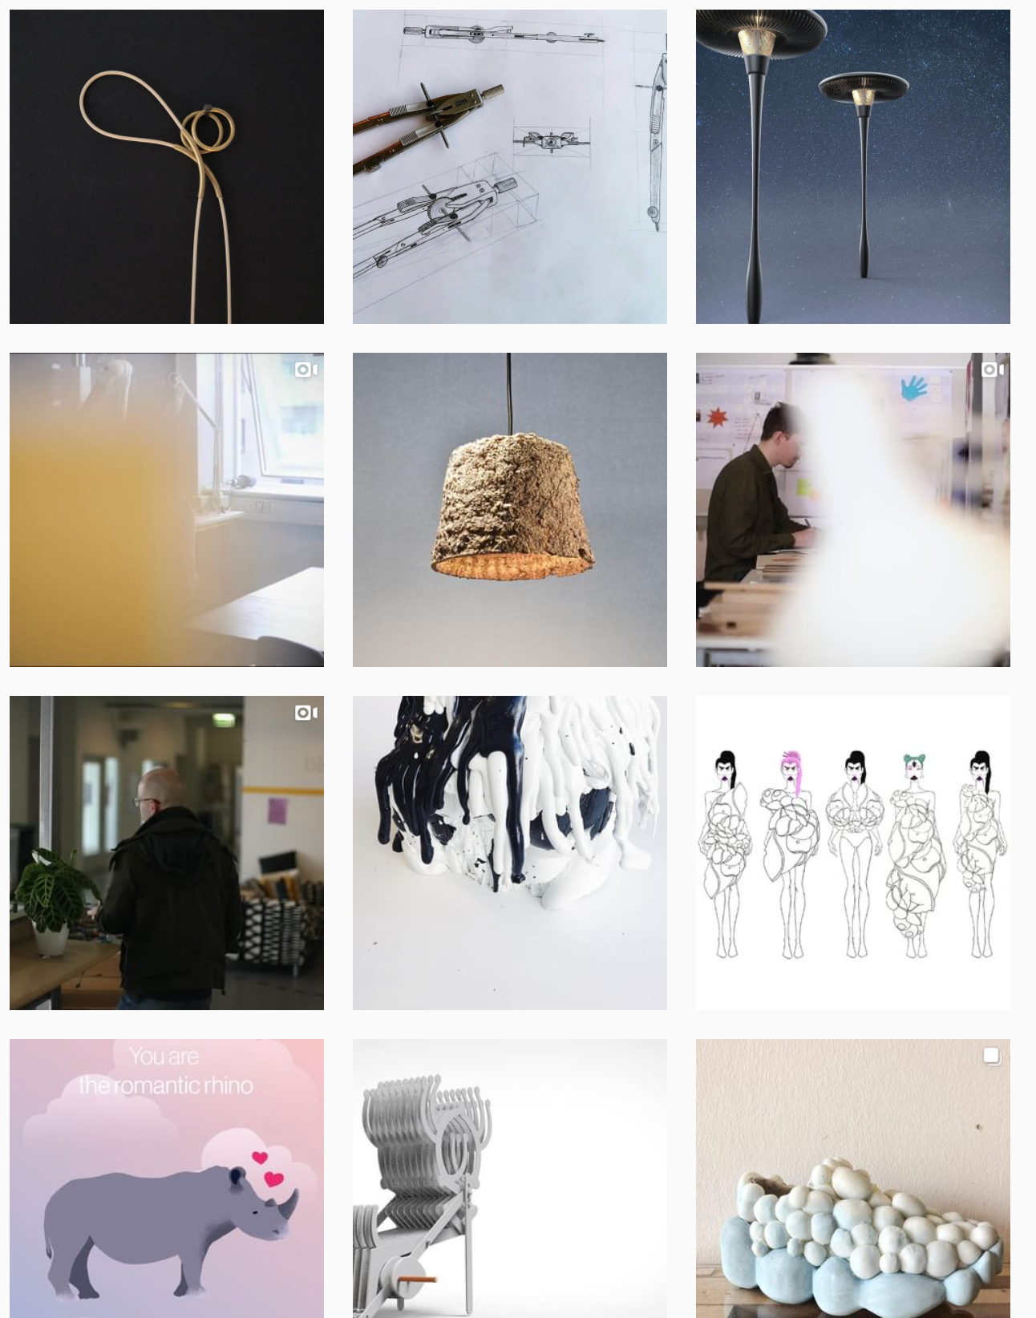
- Edit your images. You can edit in Instagram or you can use free editing apps such as VSCO or Snapseed. Always tone down yellowish light. If you use a filter, use the same filter for all your images.

DESIGN SCHOOL KOLDING INSTAGRAM FEED

INSPIRATION

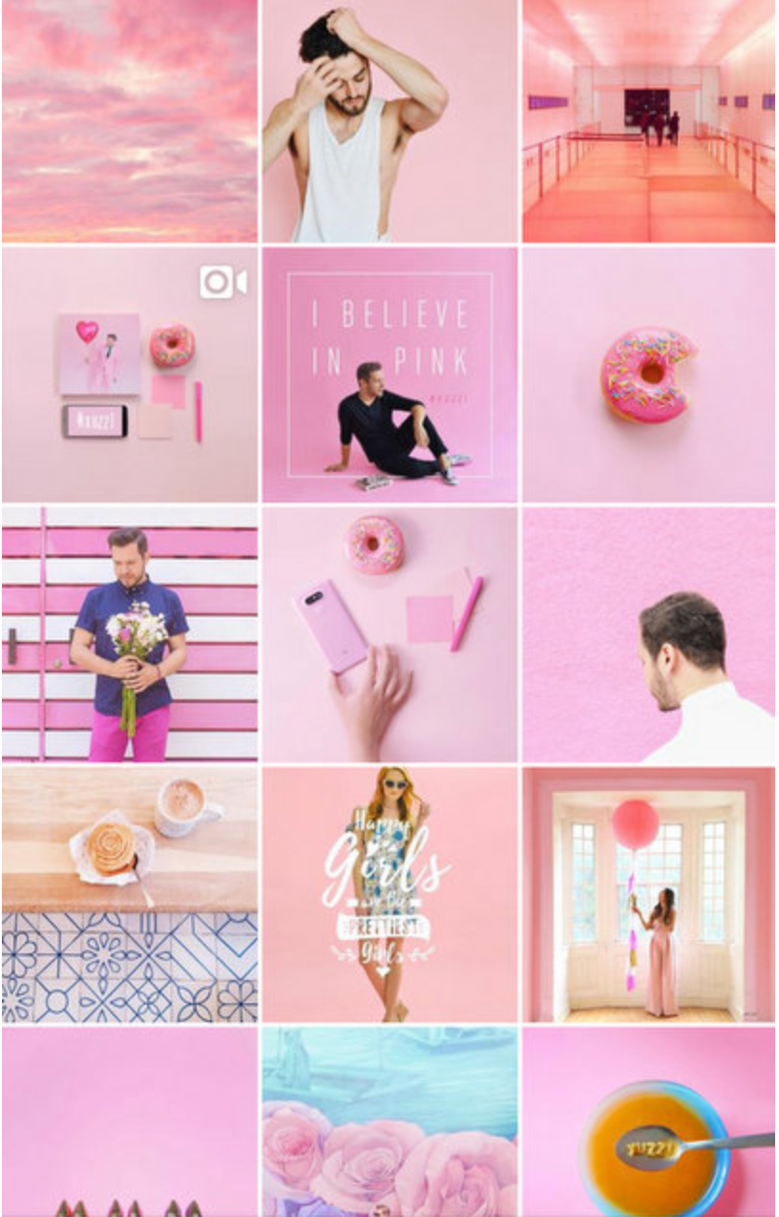



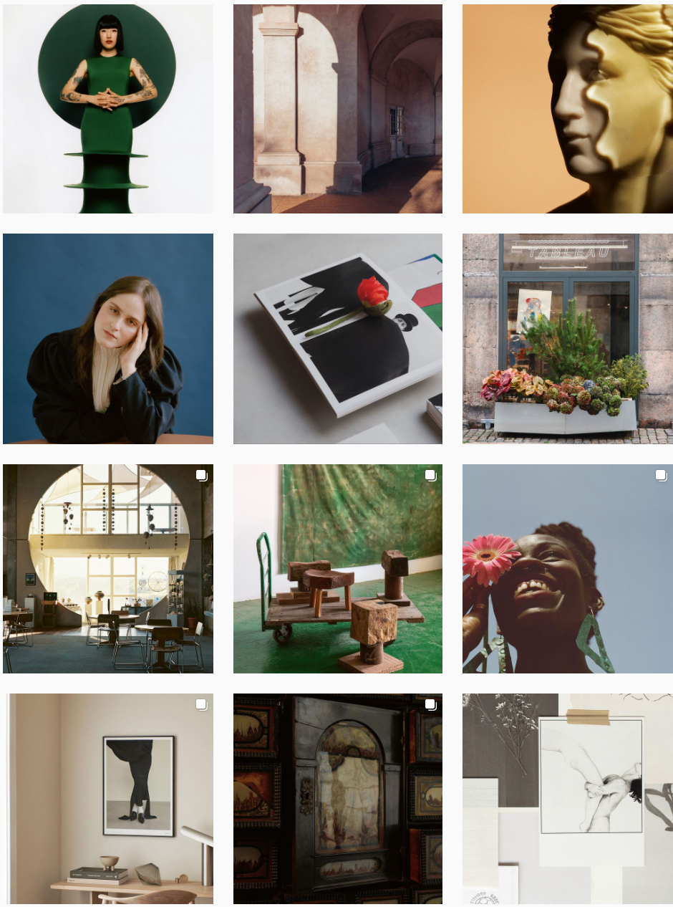

POST EXAMPLES

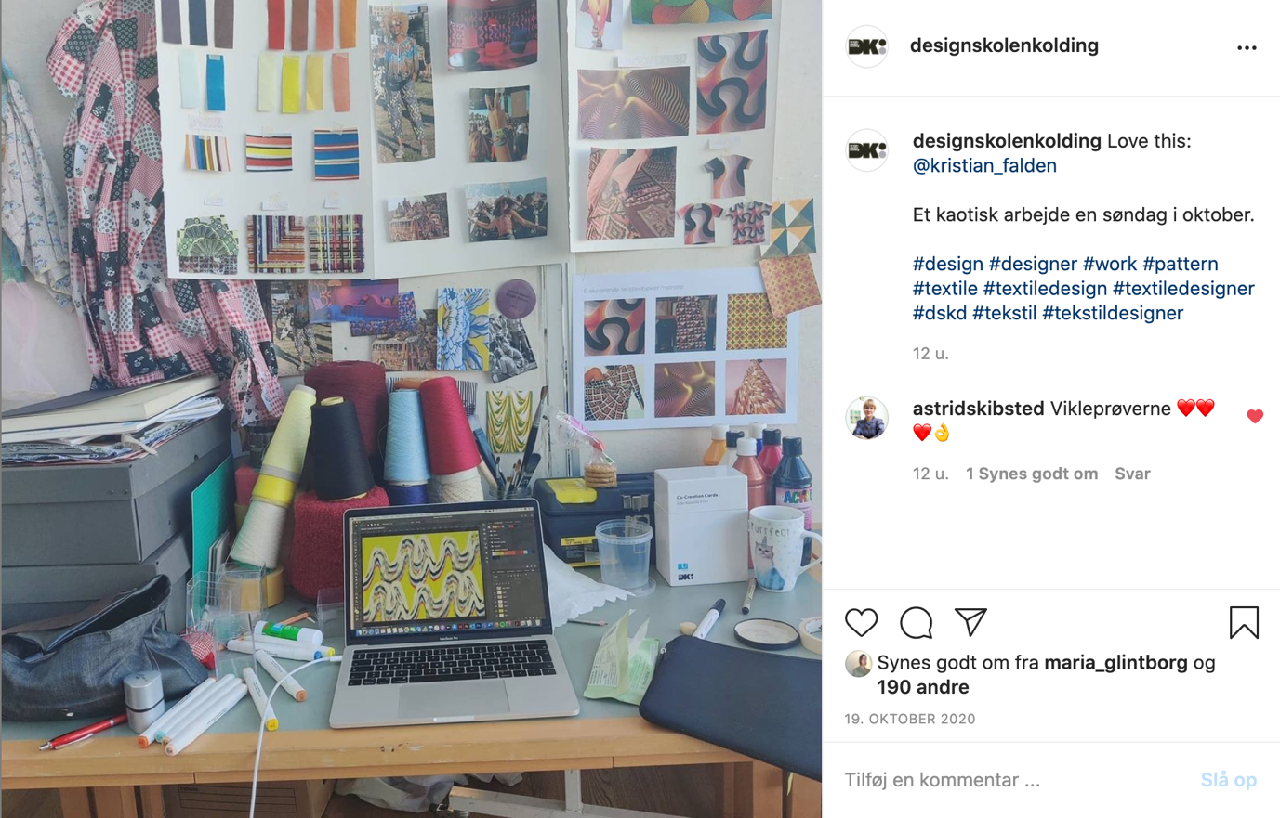

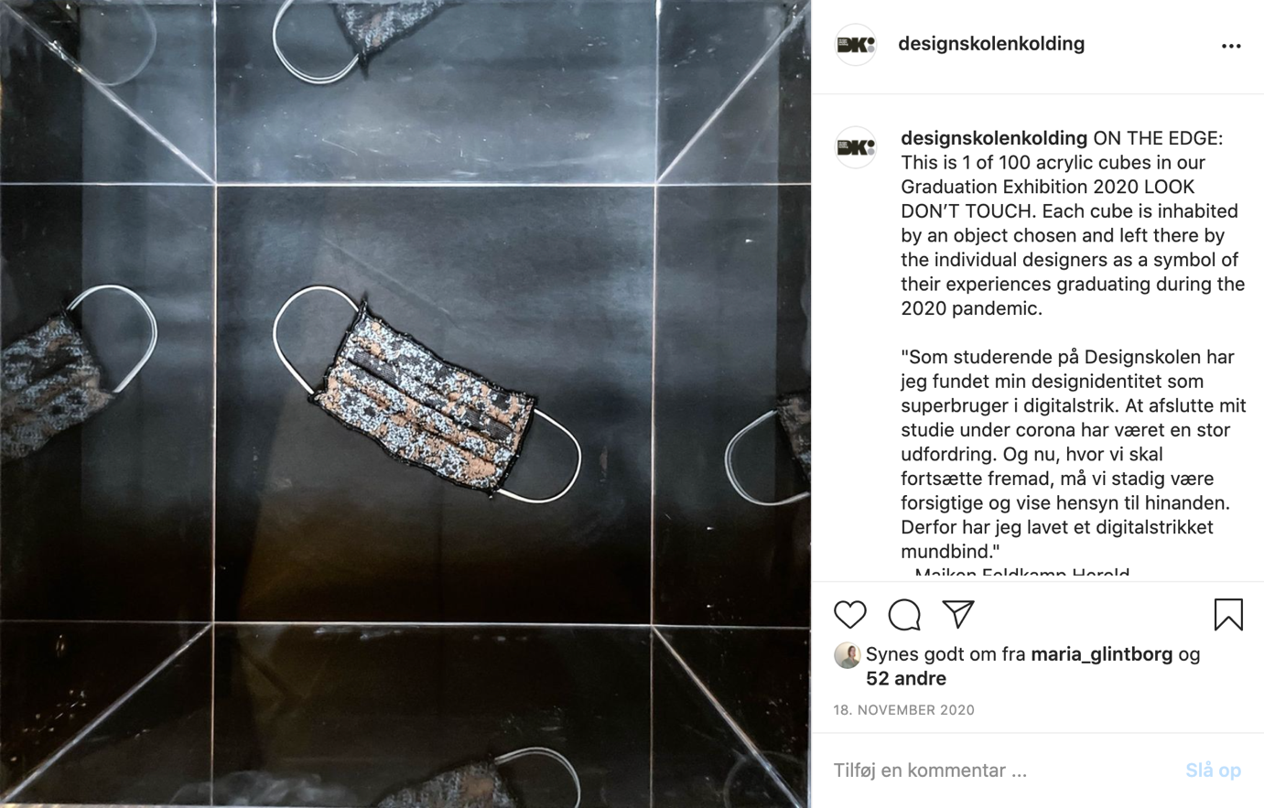



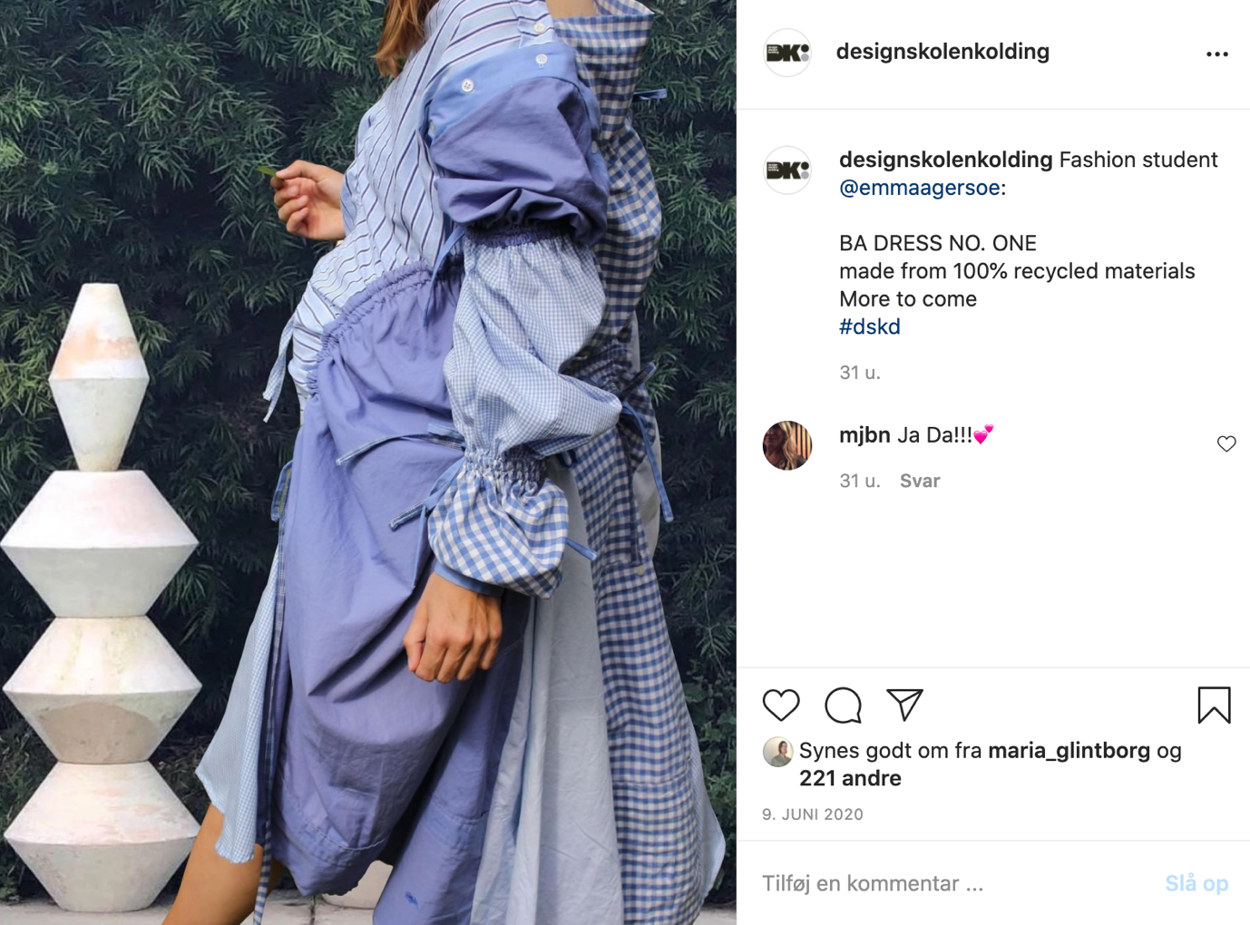

- Upload several images (1-3) a day but not all at once. If you do, you can upload more images in one post - or create a collage.
- Use the right hashtags. Instagram allows 30 hashtags with each post, but limit yours to approx 15. Make sure the hashtags match your post.
- Shift to a company profile: Gives you access to knowledge about your users and reach, etc. A company profile requires a Facebook profile.
- Use GEO-tag, meaning add your location. In most cases this will probably be Design School Kolding.
- Engage with your followers: like, share, comment. If you show an interest in them, they are likely to return that interest.
- Make stories: The essence of Instagram is well-produced visual content. Instagram Story is the unpolished little brother. Story is your chance to create fleeting, cheerful, snapchat-like content (image or 10-second video) where you engage with your users differently from what is possible with a square image. Often you will be able to establish a more loyal set of followers if you show images that are not as Insta-friendly as the ones in your feed, but still represent what goes on probably 99% of the time. Your story-feed gives you the change to create ‘un-pretty’ content ;)
- Your story lives for 24 hours but you can lock it in your feed under ’highlights’ to make it permanent. Highlight only the stories that make sense. Make sure to remove story highlights where the content no longer is relevant.

